- Head of the Department,
Leather Technology.
- Incharge,
Wood Technology.

No: KGP/Estt/2026/353 Dated:21-05-2026

Subject: Submission of Details of Wood Technology & Leather Technology Branches – Compliance with Hon’ble Deputy Chief Minister’s Directions.
Ref: Recent Visit of Hon’ble Deputy Chief Minister and Minister of Skill Development.

Sir,
As per the recent visit of the Hon’ble Deputy Chief Minister and Minister of Skill Development to our institution, directions were issued to submit detailed information regarding those branches where admissions are not being done or where the dropout rate is high.
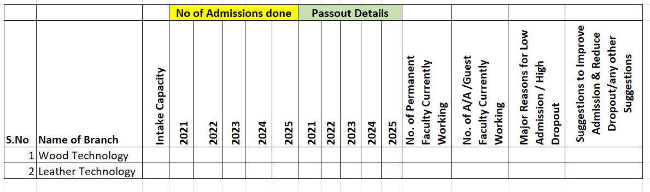
In compliance with the above directions, you are hereby directed to provide the complete details of your respective branches, i.e. Leather Technology and Wood Technology, in the prescribed format for onward submission to the higher authorities. Kindly fill in the details as per the format given below and submit the same within 2 days (by 23rd May 2026). You may also provide additional details / remarks / clarifications / reasons wherever necessary for better understanding of the ground situation.

Principal
Kashmir Government Polytechnic College
Srinagar

